

| **Title:** Implementation of fuzzy operations (COMPLEMENT, UNION ,INTERSECTION) on fuzzy sets. |
| --- |

**____________________________________________________________________________________**

**Objective:** To understand fuzzy operations

**____________________________________________________________________________________**

**Expected Outcome of Experiment:**

**CO4 :** Apply basics of Fuzzy logic and neural networks **____________________________________________________________________________________**

**Books/ Journals/ Websites referred:**

____________________________________________________________________________________

**Pre Lab/ Prior Concepts:**

**Fuzzy logic:**

Fuzzy logic extends classical logic to handle the concept of partial truth, with values ranging from "completely true" to "completely false." Unlike traditional binary logic, where variables are strictly true or false, fuzzy logic allows for degrees of truth. This is particularly useful in scenarios involving uncertain or vague data, such as natural language processing and control systems.

**Definition of fuzzy set:**

A fuzzy set is a collection of elements where each element has a degree of membership ranging between 0 and 1. This degree indicates the extent to which the element belongs to the set. For example, in the fuzzy set of "tall people," someone who is 180 cm tall might have a membership value of 0.8, indicating they are somewhat tall, while someone who is 150 cm tall might have a membership value of 0.2.

**Fuzzy set operations:**

Fuzzy set operations extend classical set operations to handle membership values:

* Union: The union of two fuzzy sets A and B (denoted as A∪B) is calculated by taking the maximum membership value of each element: μA∪B(x)=max⁡(μA(x),μB(x)).
* Intersection: The intersection of two fuzzy sets A and B (denoted as A∩B) is calculated by taking the minimum membership value of each element: μA∩B(x)=min⁡(μA(x),μB(x)).
* Complement: The complement of a fuzzy set A (denoted as ¬A) is calculated by subtracting the membership value of each element from 1: μ¬A(x)=1−μA(x).

**Fuzzy inference system**

A fuzzy inference system (FIS) is a framework that uses fuzzy logic to map inputs to outputs. It involves several steps:

1. Fuzzification: Converting crisp input values into fuzzy values using membership functions.
2. Rule Evaluation: Applying fuzzy rules (e.g., IF-THEN statements) to the fuzzy input values to generate fuzzy outputs.
3. Aggregation: Combining the outputs of all fuzzy rules.
4. Defuzzification: Converting the aggregated fuzzy output back into a crisp value.

Fuzzy inference systems are commonly used in control systems, decision-making applications, and pattern recognition.

____________________________________________________________________________________

**Implementation Details:**

1. Implement the fuzzy operations- Union, intersection, compliment and visualize the same.

Code:

import matplotlib.pyplot as plt

import numpy as np

# Define the membership functions for two fuzzy sets

*def* fuzzy_set_A(*x*):

    if *x* < 0 or *x* > 60:

        return 0

    elif *x* <= 30:

        return *x* / 30

    else:

        return (60 - *x*) / 30

*def* fuzzy_set_B(*x*):

    if *x* < 0 or *x* > 100:

        return 0

    elif *x* <= 50:

        return *x* / 50

    else:

        return (100 - *x*) / 50

# Define the union, intersection, and complement operations

*def* fuzzy_union(*a*, *b*):

    return max(*a*, *b*)

*def* fuzzy_intersection(*a*, *b*):

    return min(*a*, *b*)

*def* fuzzy_complement(*a*):

    return 1 - *a*

# Generate x values

x = np.linspace(0, 100, 500)

A = np.array([fuzzy_set_A(xi) for xi in x])

B = np.array([fuzzy_set_B(xi) for xi in x])

# Perform fuzzy operations

union = np.array([fuzzy_union(A[i], B[i]) for i in range(len(x))])

intersection = np.array([fuzzy_intersection(A[i], B[i]) for i in range(len(x))])

complement_A = np.array([fuzzy_complement(A[i]) for i in range(len(x))])

complement_B = np.array([fuzzy_complement(B[i]) for i in range(len(x))])

# Plotting

plt.figure(*figsize*=(12, 8))

# Plot the original fuzzy sets

plt.subplot(2, 2, 1)

plt.plot(x, A, *label*='Fuzzy Set A')

plt.plot(x, B, *label*='Fuzzy Set B')

plt.title('Fuzzy Sets A and B')

plt.xlabel('x')

plt.ylabel('Membership Degree')

plt.legend()

# Plot the union

plt.subplot(2, 2, 2)

plt.plot(x, union, *label*='Union of A and B')

plt.title('Union of Fuzzy Sets A and B')

plt.xlabel('x')

plt.ylabel('Membership Degree')

plt.legend()

# Plot the intersection

plt.subplot(2, 2, 3)

plt.plot(x, intersection, *label*='Intersection of A and B')

plt.title('Intersection of Fuzzy Sets A and B')

plt.xlabel('x')

plt.ylabel('Membership Degree')

plt.legend()

# Plot the complements

plt.subplot(2, 2, 4)

plt.plot(x, complement_A, *label*='Complement of A')

plt.plot(x, complement_B, *label*='Complement of B')

plt.title('Complements of Fuzzy Sets A and B')

plt.xlabel('x')

plt.ylabel('Membership Degree')

plt.legend()

plt.tight_layout()

plt.show()

Output:

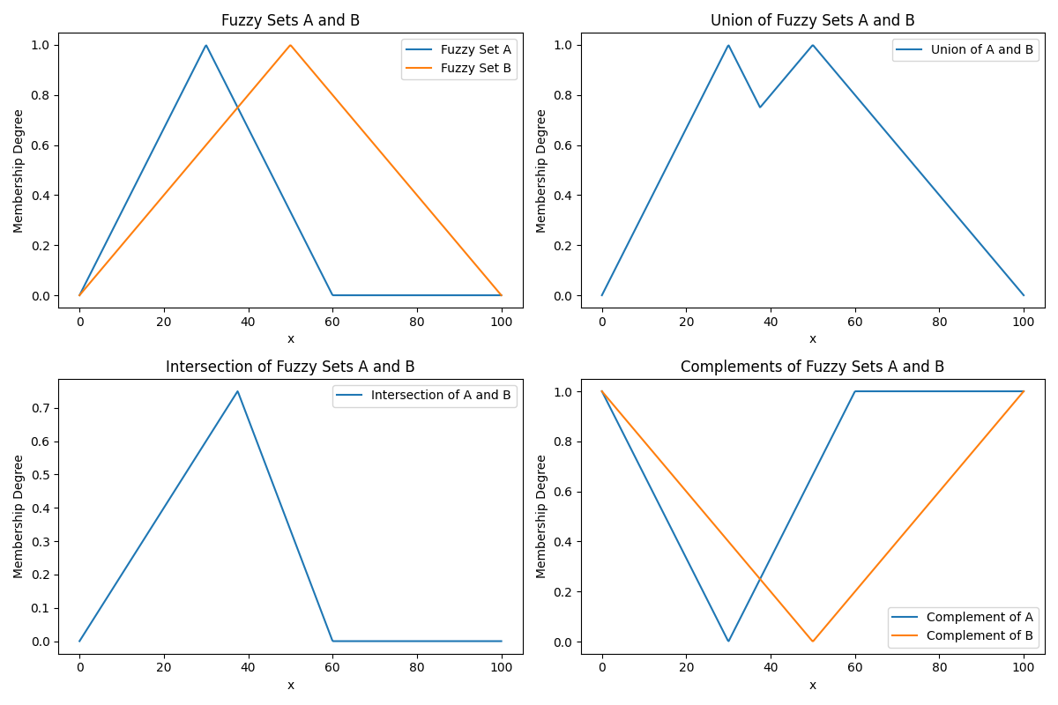

**Post Lab Descriptive Questions :**

Q1 Two fuzzy sets A and B are given with membership functions μA(x) = {0.2, 0.4, 0.8, 0.5, 0.1} μB(x) = {0.1, 0.3, 0.6, 0.3, 0.2} Then the value of μ ––– will be A∩B  
(A) {0.9, 0.7, 0.4, 0.8, 0.9}  
(B) {0.2, 0.4, 0.8, 0.5, 0.2}  
(C) {0.1, 0.3, 0.6, 0.3, 0.1}  
(D) {0.7, 0.3, 0.4, 0.2, 0.7}

Ans: (C) {0.1, 0.3, 0.6, 0.3, 0.1}

Q2 The height h(A) of a fuzzy set A is defined as h(A) =sup A(x) where x belongs to A. Then the fuzzy set A is called normal when

(A)h(A)=0

(B)h(A)<0

(C)h(A)=1

(D)h(A)<1

Ans: (C) h(A)=1

Q3 If A and B are two fuzzy sets with membership functions μA(x) = {0.6, 0.5, 0.1, 0.7, 0.8} μB(x) = {0.9, 0.2, 0.6, 0.8, 0.5}

Then the value of μ Complement A∪B(x) will be

(A) {0.9, 0.5, 0.6, 0.8, 0.8}

(B) {0.6, 0.2, 0.1, 0.7, 0.5}

(C) {0.1, 0.5, 0.4, 0.2, 0.2}

(D){0.1,0.5,0.4,0.2,0.3}

Ans: (C) {0.1, 0.5, 0.4, 0.2, 0.2}

**Date: 10/10/24 Signature of faculty in-charge**